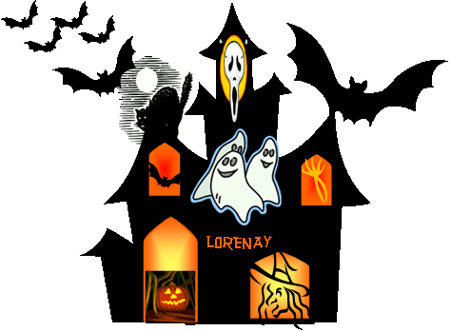
Luiseño School Proudly Presents
Halloween Activity Night & Dance!
Friday, October 18th , from 3:00-5:00 PM
$5.00 donation in cash or check
(Make checks payable to Luiseño School)

**KONA ICE AND HOT DIGGITY DOG WILL SELLING ITEMS**

Eat, dance, and play
- School rules & Dress code apply.
- Please wear costumes!!
- Games and activities will be there such as: bean bag toss,
giant jenga and guess the candy corn!
- Cookie decorating and guess the candy corn, will also be happening at this event!

Simple rules apply at the dance as well:
- The school dress code is in effect during this dance, and MUST be followed.
- School rules are in effect during the dance as well. We are a NO TOUCH SCHOOL, so keep the “dance space” open around you! Rules must be followed, or you will be sent home. You will lose eligibility for future events if a violation occurs.
- This dance is for Luiseño’s 6th, 7th and 8th grade students only.
(No guests from other schools or siblings are allowed)
- Tickets will be available in Mrs. Kern’s Office from
Wednesday, October 9th to Thursday, October 17th at 3:00 pm.
TICKETS WILL NOT BE AVAILABLE AFTER 3:00 PM ON THURSDAY, October 17th .

*Students with suspensions (on or off campus), or PBI within this semester,
are NOT eligible to attend.

*Bring this portion of the signed permission slip with you to get your ticket*
THIS FORM MUST BE TURNED IN by 3:00 PM THURSDAY, October 17th
You will not be allowed to attend the dance without a permission slip.
(We will not be calling parents to get permission over the phone on the day of the dance.)
I give my permission for my student to attend the dance at Luiseno school. My student will be picked up when the dance ends at 5:00pm.
I understand any student that does not go home between school and the dance, must stay in room 25 (Mrs. Ford’s Classroom) from 2:00 – 3:00pm.
Student’s Name: _______________________________________________advisory period Teacher____________
Student’s Address: _____________________________________________________________________________________
Parent/Guardian’s Telephone Number: (_______) _____________________________________________________
(the phone number should be where you can be reached during the event if needed.)
Parent/Guardian Signature: ________________________________Printed name: _________________________
Please sign below if your student is permitted to walk home of the conclusion of the dance (they will not be permitted to leave the dance until it is over)
Parent/Guardian Signature: ________________________________printed name: __________________________

